**Kgaogelo Sekhaolelo**

**Student no: ST10097375**

**Advanced Databases Assignment**

Table of Contents

**--Question1** 1

--Question2 2

--Question3 8

--Question4 8

--Question5 9

--Question6 11

--Question7 13

--Question8 16

--Question9 16

# **--Question1**

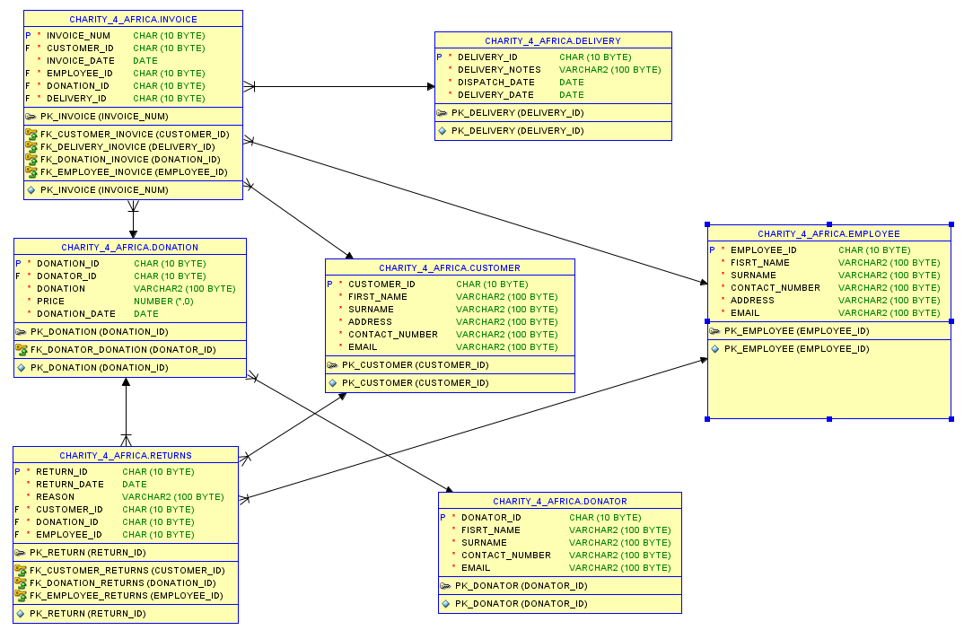

# --Question2

CREATE TABLE CUSTOMER(

CUSTOMER_ID CHAR(10) NOT NULL,

FIRST_NAME VARCHAR2(100) NOT NULL,

SURNAME VARCHAR2(100) NOT NULL,

ADDRESS VARCHAR2(100) NOT NULL,

CONTACT_NUMBER VARCHAR2(100) NOT NULL,

EMAIL VARCHAR2(100) NOT NULL,

CONSTRAINT PK_CUSTOMER PRIMARY KEY (CUSTOMER_ID)

);

CREATE TABLE EMPLOYEE(

EMPLOYEE_ID CHAR(10) NOT NULL,

FISRT_NAME VARCHAR2(100) NOT NULL,

SURNAME VARCHAR2(100) NOT NULL,

CONTACT_NUMBER VARCHAR2(100) NOT NULL,

ADDRESS VARCHAR2(100) NOT NULL,

EMAIL VARCHAR2(100) NOT NULL,

CONSTRAINT PK_EMPLOYEE PRIMARY KEY (EMPLOYEE_ID)

);

CREATE TABLE DONATOR(

DONATOR_ID CHAR(10) NOT NULL,

FISRT_NAME VARCHAR2(100) NOT NULL,

SURNAME VARCHAR2(100) NOT NULL,

CONTACT_NUMBER VARCHAR2(100) NOT NULL,

EMAIL VARCHAR2(100) NOT NULL,

CONSTRAINT PK_DONATOR PRIMARY KEY (DONATOR_ID)

);

CREATE TABLE DONATION(

DONATION_ID CHAR(10) NOT NULL,

DONATOR_ID CHAR(10) NOT NULL,

DONATION VARCHAR2(100) NOT NULL,

PRICE INT NOT NULL,

DONATION_DATE DATE NOT NULL,

CONSTRAINT PK_DONATION PRIMARY KEY (DONATION_ID),

CONSTRAINT FK_DONATOR_DONATION FOREIGN KEY (DONATOR_ID) REFERENCES DONATOR(DONATOR_ID)

);

CREATE TABLE DELIVERY(

DELIVERY_ID CHAR(10) NOT NULL,

DELIVERY_NOTES VARCHAR2(100) NOT NULL,

DISPATCH_DATE DATE NOT NULL,

DELIVERY_DATE DATE NOT NULL,

CONSTRAINT PK_DELIVERY PRIMARY KEY (DELIVERY_ID)

);

CREATE TABLE RETURNS(

RETURN_ID CHAR(10) NOT NULL,

RETURN_DATE DATE NOT NULL,

REASON VARCHAR2(100) NOT NULL,

CUSTOMER_ID CHAR(10) NOT NULL,

DONATION_ID CHAR(10) NOT NULL,

EMPLOYEE_ID CHAR(10) NOT NULL,

CONSTRAINT PK_RETURN PRIMARY KEY (RETURN_ID),

CONSTRAINT FK_CUSTOMER_RETURNS FOREIGN KEY (CUSTOMER_ID) REFERENCES CUSTOMER(CUSTOMER_ID),

CONSTRAINT FK_DONATION_RETURNS FOREIGN KEY (DONATION_ID) REFERENCES DONATION(DONATION_ID),

CONSTRAINT FK_EMPLOYEE_RETURNS FOREIGN KEY (EMPLOYEE_ID) REFERENCES EMPLOYEE(EMPLOYEE_ID)

);

CREATE TABLE INVOICE(

INVOICE_NUM CHAR(10) NOT NULL,

CUSTOMER_ID CHAR(10) NOT NULL,

INVOICE_DATE DATE NOT NULL,

EMPLOYEE_ID CHAR(10) NOT NULL,

DONATION_ID CHAR(10) NOT NULL,

DELIVERY_ID CHAR(10) NOT NULL,

CONSTRAINT PK_INVOICE PRIMARY KEY (INVOICE_NUM),

CONSTRAINT FK_CUSTOMER_INOVICE FOREIGN KEY (CUSTOMER_ID) REFERENCES CUSTOMER(CUSTOMER_ID),

CONSTRAINT FK_EMPLOYEE_INOVICE FOREIGN KEY (EMPLOYEE_ID) REFERENCES EMPLOYEE(EMPLOYEE_ID),

CONSTRAINT FK_DONATION_INOVICE FOREIGN KEY (DONATION_ID) REFERENCES DONATION(DONATION_ID),

CONSTRAINT FK_DELIVERY_INOVICE FOREIGN KEY (DELIVERY_ID) REFERENCES DELIVERY(DELIVERY_ID)

);

INSERT INTO CUSTOMER VALUES('11011','Jack','Smith','18 Water Rd','087 727 7521','jsmith@isat.com');

INSERT INTO CUSTOMER VALUES('11012','Pat','Hendricks','22 Water Rd','086 325 7857','ph@mcom.co.za');

INSERT INTO CUSTOMER VALUES('11013','Andre','Clark','101 Summer Lane','083 456 7891','aclack@mcom.co.za');

INSERT INTO CUSTOMER VALUES('11014','Kevin','Jones','55 Mountain way','061 254 7895','kj@isat.co.za');

INSERT INTO CUSTOMER VALUES('11015','Lucy','Williams','5 Main rd','082 723 8521','lw@mcal.co.za');

INSERT INTO EMPLOYEE VALUES('emp101','Jeff','Davis','087 727 7521','10 main road','jand@isat.com');

INSERT INTO EMPLOYEE VALUES('emp102','Kevin','Marks','083 737 7522','18 water road','km@isat.com');

INSERT INTO EMPLOYEE VALUES('emp103','Adanya','Andrews','081 711 7523','21 circle lane','aa@isat.com');

INSERT INTO EMPLOYEE VALUES('emp104','Adebayo','Dryer','079 721 5244','1 sea road ','aryer@isat.com');

INSERT INTO EMPLOYEE VALUES('emp105','Xolani','Samson','082 712 2255','12 main road','xosam@isat.com');

INSERT INTO DONATOR VALUES('20111','Jeff','Watson','082 717 2250','jwatson@ymail.com');

INSERT INTO DONATOR VALUES('20112','Stephen','Jones','083 786 5670','joness@ymail.com');

INSERT INTO DONATOR VALUES('20113','James','Joe','087 897 8650','jj@ymail.com');

INSERT INTO DONATOR VALUES('20114','Kelly','Ross','082 657 5650','kross@ymail.com');

INSERT INTO DONATOR VALUES('20115','Abraham','Clark','079 765 6430','aclark@ymail.com');

INSERT INTO DONATION VALUES('7111','20111','KIC Fridge','599','1 May 2022');

INSERT INTO DONATION VALUES('7112','20112','Samsung 42inch','1299','3 May 2022');

INSERT INTO DONATION VALUES('7113','20113','Sharp Mircowave','1599','3 May 2022');

INSERT INTO DONATION VALUES('7114','20115','6 Seat Dining room table','799','5 May 2022');

INSERT INTO DONATION VALUES('7115','20114','Lazyboy Sofa','1199','7 May 2022');

INSERT INTO DONATION VALUES('7116','20113','JVC Surround Sound System','179','9 May 2022');

INSERT INTO DELIVERY VALUES('511','Double packaging requested','10 May 2022','15 May 2022');

INSERT INTO DELIVERY VALUES('512','Delivery to work address','12 May 2022','15 May 2022');

INSERT INTO DELIVERY VALUES('513','Signature required','12 May 2022','17 May 2022');

INSERT INTO DELIVERY VALUES('514','No notes','12 May 2022','15 May 2022');

INSERT INTO DELIVERY VALUES('515','Birthday present wrapping required','18 May 2022','19 May 2022');

INSERT INTO DELIVERY VALUES('516','Delivery to work address','20 May 2022','25 May 2022');

INSERT INTO RETURNS VALUES('ret001','25 May 2022','Customer not satisfied with product','11011','7116','emp101');

INSERT INTO RETURNS VALUES('ret002','25 May 2022','Product had broken section','11013','7114','emp103');

INSERT INTO INVOICE VALUES('8111','11011','15 May 2022','emp103','7111','511');

INSERT INTO INVOICE VALUES('8112','11013','15 May 2022','emp101','7114','512');

INSERT INTO INVOICE VALUES('8113','11012','17 May 2022','emp101','7112','513');

INSERT INTO INVOICE VALUES('8114','11015','17 May 2022','emp102','7113','514');

INSERT INTO INVOICE VALUES('8115','11011','17 May 2022','emp102','7115','515');

INSERT INTO INVOICE VALUES('8116','11015','18 May 2022','emp103','7116','516');

# --Question3

SELECT customer.FIRST_NAME, employee.EMPLOYEE_ID,donation.DONATION, delivery.DELIVERY_NOTES, invoice.INVOICE_NUM, invoice.INVOICE_DATE

FROM employee INNER JOIN invoice ON employee.EMPLOYEE_ID = invoice.EMPLOYEE_ID

INNER JOIN customer ON invoice.CUSTOMER_ID = customer.CUSTOMER_ID

INNER JOIN delivery ON invoice.DELIVERY_ID = delivery.DELIVERY_ID

INNER JOIN donation ON invoice.DONATION_ID = donation.DONATION_ID

WHERE invoice.INVOICE_DATE >= '18 May 2022';



----VARCHAR2: datatype that specifies a variable-length character string in the database character set.

----CHAR: datatype that stores fixed-length character strings.

# --Question4

--Q.4.1

CREATE OR REPLACE VIEW Question4

AS

SELECT employee.EMPLOYEE_ID, employee.FISRT_NAME, employee.SURNAME, invoice.INVOICE_DATE

FROM employee, invoice

WHERE invoice.INVOICE_DATE = '18 May 2022' AND employee.EMPLOYEE_ID = 'emp103';

SELECT * FROM Question4;



--Q.4.2

* View in Oracle: is a named, validated SQL query kept in the data dictionary of the Oracle Database (Staff, 2020:07).
* **Two benefits gained by CHARITY 4 AFRICA for using the View**

**-** (1) Views will provide an additional level of security by restricting access to predetermined set of rows and columns of a table (Staff, 2020:07).

- (2) View can be used to hide some of the columns from the table (Staff, 2020:07).

# --Question5

SET SERVEROUTPUT ON;

DECLARE

v_Customer customer.FIRST_NAME%TYPE;

v_DonationP donation.DONATION%TYPE;

v_Price donation.PRICE%TYPE;

v_ReturnReason returns.REASON%TYPE;

CURSOR info

IS

SELECT customer.FIRST_NAME||' '||customer.SURNAME AS CUSTOMER, donation.DONATION, donation.PRICE,returns.REASON

FROM returns INNER JOIN customer ON customer.CUSTOMER_ID = returns.CUSTOMER_ID

INNER JOIN donation ON returns.DONATION_ID = donation.DONATION_ID

ORDER BY customer.FIRST_NAME;

BEGIN

OPEN info;

LOOP

FETCH info INTO v_Customer, v_DonationP, v_Price, v_ReturnReason ;

EXIT WHEN info%NOTFOUND;

DBMS_OUTPUT.PUT_LINE('_______________________________________________');

DBMS_OUTPUT.PUT_LINE('CUSTOMER:  :'||v_Customer);

DBMS_OUTPUT.PUT_LINE('DONATION PURCHASED :'||v_DonationP);

DBMS_OUTPUT.PUT_LINE('DONATION PURCHASED :'||v_Price);

DBMS_OUTPUT.PUT_LINE('DONATION PURCHASED :'||v_ReturnReason);

DBMS_OUTPUT.PUT_LINE('---------------------------------------------');

END LOOP;

CLOSE info;

END;

/

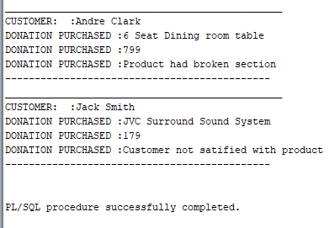

# --Question6

--Q.6.1

SET SERVEROUTPUT ON;

DECLARE

v_Customer customer.FIRST_NAME%TYPE;

v_Employee employee.FISRT_NAME%TYPE;

v_Donation donation.DONATION%TYPE;

v_Dis DATE;

v_Delivery DATE;

v_Daystodelivery INT;

CURSOR info

IS

SELECT customer.FIRST_NAME||','||customer.SURNAME AS CUSTOMER,employee.

FISRT_NAME||','||employee.SURNAME AS EMPLOYEE,

donation.DONATION,delivery.DISPATCH_DATE,delivery.DELIVERY_DATE,round(delivery.DELIVERY_DATE - delivery.DISPATCH_DATE) AS_DAYS_TO_DELIVERY

FROM invoice

INNER JOIN customer ON invoice.CUSTOMER_ID = customer.CUSTOMER_ID

INNER JOIN employee ON invoice.EMPLOYEE_ID = employee.EMPLOYEE_ID

INNER JOIN donation ON invoice.DONATION_ID = donation.DONATION_ID

INNER JOIN delivery ON invoice.DELIVERY_ID = delivery.DELIVERY_ID

WHERE customer.CUSTOMER_ID = '11013';

BEGIN

OPEN info;

LOOP

FETCH info INTO v_Customer,v_Employee,v_Donation,v_Dis,v_Delivery, v_Daystodelivery;

EXIT WHEN info%NOTFOUND;

DBMS_OUTPUT.PUT_LINE('-------------------------------------------------');

DBMS_OUTPUT.PUT_LINE('CUSTOMER :'||v_Customer);

DBMS_OUTPUT.PUT_LINE('EMPLOYEE :'||v_Employee);

DBMS_OUTPUT.PUT_LINE('DONATION :'||v_Donation);

DBMS_OUTPUT.PUT_LINE('DISPATCH DATE :'||v_Dis);

DBMS_OUTPUT.PUT_LINE('DELIVERY DATE :'||v_Delivery);

DBMS_OUTPUT.PUT_LINE('CUSTOMER :'||v_Daystodelivery);

DBMS_OUTPUT.PUT_LINE('--------------------------------------------------');

END LOOP;

CLOSE info;

END;

/

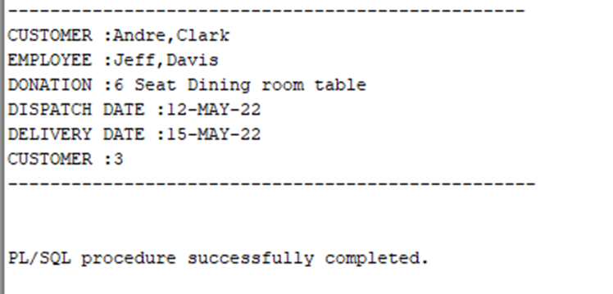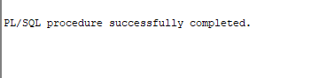

--Q.6.2

---(a) DATE datatype: is used to store fixed-length datetimes, which include the time of day in seconds since midnight (Johnston,2000:08)

---(b) Character: Alphanumeric values that represent single characters or strings of characters (Johnston,2000:08).

# --Question7

--Q.7.1

SET SERVEROUTPUT ON;

DECLARE

v_CustomerID customer.CUSTOMER_ID%TYPE;

v_DonationID donation.DONATION_ID%TYPE;

v_DonatorID donator.DONATOR_ID%TYPE;

v_DeliveryID delivery.DELIVERY_ID%TYPE;

v_ReturnID returns.RETURN_ID%TYPE;

v_ReturnReason returns.REASON%TYPE;

v_Price INT;

CURSOR info

IS

SELECT customer.CUSTOMER_ID,donation.DONATION_ID,donator.DONATOR_ID,returns.RETURN_ID, delivery.DELIVERY_ID, returns.REASON,

donation.PRICE *0.2 AS DELIVERY_PRICE

FROM customer

INNER JOIN invoice ON customer.CUSTOMER_ID = invoice.CUSTOMER_ID

INNER JOIN donation ON invoice.DONATION_ID = donation.DONATION_ID

INNER JOIN donator ON donator.DONATOR_ID = donation.DONATOR_ID

INNER JOIN delivery ON invoice.DELIVERY_ID = delivery.DELIVERY_ID

INNER JOIN returns ON returns.DONATION_ID = donation.DONATION_ID

WHERE delivery.DELIVERY_ID = '512';

BEGIN

OPEN info;

LOOP

FETCH info INTO v_CustomerID, v_DonationID, v_DonatorID, v_DeliveryID, v_ReturnID, v_ReturnReason,v_Price;

EXIT WHEN info%NOTFOUND;

DBMS_OUTPUT.PUT_LINE('CUSTOMER :'||v_CustomerID);

DBMS_OUTPUT.PUT_LINE('DONATION ID:'||v_DonationID);

DBMS_OUTPUT.PUT_LINE('DONATOR ID :'||v_DonatorID);

DBMS_OUTPUT.PUT_LINE('DELIVERY ID: :'||v_DeliveryID);

DBMS_OUTPUT.PUT_LINE('RETURN ID: :'||v_ReturnID);

DBMS_OUTPUT.PUT_LINE('RETURN REASON: :'||v_ReturnReason);

DBMS_OUTPUT.PUT_LINE('DELIVERY PRICE: :'||v_Price);

END LOOP;

CLOSE info;

END;

/

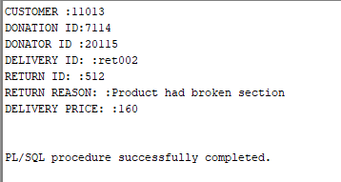

--Q.7.2

--(a) Multiplication: is one of the four basic arithmetic operations, alongside addition, subtraction, and division (Interview, 2017:05).

--(b) Attribute indicator: property which let the user reference the data type and structure of a present item without having to repeat its definition (Interview, 2017:05).

# --Question8

--Q.8.1

DELETE FROM employee

WHERE employee.EMPLOYEE_ID = ' emp104';

SELECT * FROM employee;

ROLLBACK;

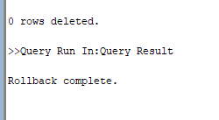

--Q.8.2 I have used the rollblock statement for the delete transaction to be reversed.

# --Question9

--Q.9.1

CREATE TABLE FUNDING(

FUNDING_ID INT NOT NULL,

FUNDER_NAME VARCHAR2(100) NOT NULL,

FUNDING_AMOUNT INT NOT NULL,

CONSTRAINT PK_FUNDING PRIMARY KEY (FUNDING_ID)

);

INSERT INTO FUNDING(FUNDER_NAME,FUNDING_AMOUNT)

VALUES('Charlotte Paul',40000);

CREATE SEQUENCE seq_funding_id;

CREATE TRIGGER Fund

BEFORE INSERT ON FUNDING

FOR EACH ROW

BEGIN

SELECT seq_funding_id.nextval

INTO :new.FUNDING_ID

FROM dual;

END;

SELECT FUNDING_ID,FUNDER_NAME,FUNDING_AMOUNT

FROM FUNDING

ORDER BY FUNDING_ID;



--Q.9.2 Record id tool: creates a new column in the data and assigns a unique identifier, that increases sequentially, for each record in the data (Version, 2023:11).

**Reference list**

https://community.alteryx.com

[https://www.tutorialspoint.com](https://www.tutorialspoint.com/plsql/plsql_data_types.htm)

[https://docs.oracle.com](https://docs.oracle.com )